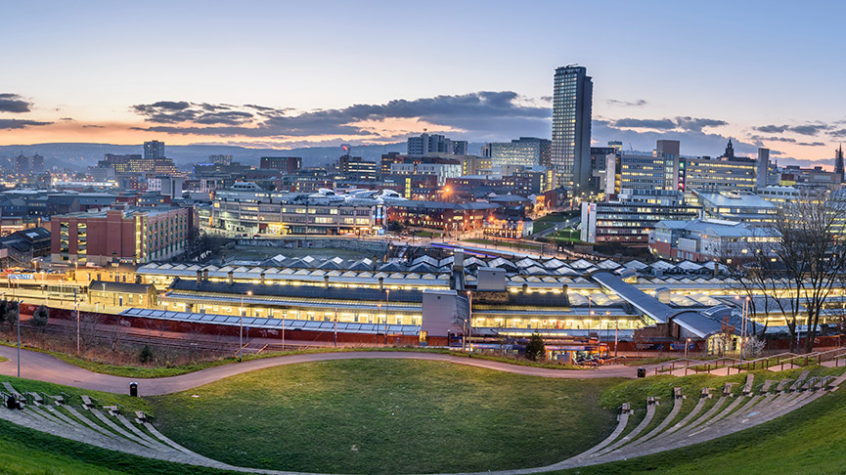
Loxley School

Y6 Staff & Parents Communication Sheet

Dear Parent,

The following information will help you support your child’s learning this half term (Spring 1) in their class with Mrs Taylor.

Details of work covered this half term:

Literacy | Descriptive stories: Stories based on the short video ‘Alma’ focusing on description and sentence openers.  Book reviews: Focus on sentence openers in non-fiction writing.  Persuasive magazines: Create an imaginary magazine article to promote your eco-friendly city.
Maths | Statistics: Including bar graphs, line graphs, tables and pie charts.  Shape: Including measuring and calculating angles, 2d and 3d shape and area, perimeter and volume.  Position and direction: Including co-ordinates, reflection and translation.
Science | Classification: Year 6 will be learning about how living things can be sorted into categories and more about micro-organisms.
Topic  History | Settlements: Year 6 will be investigating and designing sustainable eco-friendly cities.
PSHE | Identitiy: How are we the same and how do we differ? What makes me me?
Computing | Digital art: Year 6 will be producing a range of visual plans on the computer linked to Geography and DT work.
PE
DT | Bridges: Year 6 will design and build bridges out of a range of media: K’nex, paper and wood and will learn woodworking skills.
Music | Composition: Year 6 will be using keyboards to build chords and compose their own short pieces to create a mood.
Homework | Spellings – Spelling test every Wednesday (spellings on spellingshed).  Homework– To be returned by Monday and new homework issued.  Reading books – To be returned every Monday to be swapped. Please fill in the reading record about the questions and bring the record book back even if the reading book is not finished.
Boosters | Year 6 booster groups are continuing this term – check you know when your child’s sessions are.

