Home Learning

Reading books – To be returned every **Monday** to be swapped. If children are still reading the same book then books may remain at home but reading record sheets **need** to be returned weekly. Reminder letters will be issued by Mrs Taylor, with 3 non-returns being reported to Mr Connolly.

Homework – Now in homework books. Please return on a **Monday.** Homework club on **Thursday lunchtime**

Spelling – Spelling test takes place on a Wednesday pm. Please use spelling shed to check and practise spellings.

**Outside of the classroom …**

**Homework and reading club - Thursday lunchtime**

**TTRS club – Friday lunchtime**

**Additional clubs – booking on Squid**

**Please ask your child about their Y6 responsibilities and when they are timetabled for these.**

Our Learning this half term…

|  |  |
| --- | --- |
| Reading | * Retrieval, inference and vocabulary focus on Holes by Louis Sacher |
| Writing | * **Narrative writing:** Titanium music video * **Procedural writing:** Celebrations * **Grammar:** Active/passive voice and speech punctuation |
| Maths | * **Fractions:** ordering, adding, subtracting fractions * **Ratio**: Scaling, ratio language and recipes * **Measurements:** metric and imperial measurements and how to convert between |
| Science | * **Evolution** – Year 6 will be investigating the theory of evolution and the evidence that leads to this theory |
| Geography | * How **coasts** change and develop |
| History | * Who were the **Ancient Greeks**? (continued) |
| PSHE | * **Economic wellbeing:** how to be safe and sensible with money |
| Art | * **Sculpture:** Ancient Greek themed work focusing on Masks (continued) * **Perspective:** Developing the work from Y5 on 1 and 2 point persepctive |
| Computing | * **Code bugs:** Programming physical objects |
| PE **(Friday)** | * **Hockey skills and games** |
| French | * **Shopping:** conversations, clothes and money |

**Dates for your diary:**

**Wed 16th Nov**

Trip to Yorkshire Natural History museum

**Tue 14th & Mon 20th Nov**

Parents’ evenings

**Mon 11th Dec**

Friendship week

**Mon 18th Dec**

Christmas activities week – more details nearer the time

**Friday 22nd Dec**

Last day of term

**Our reading texts this term are:**

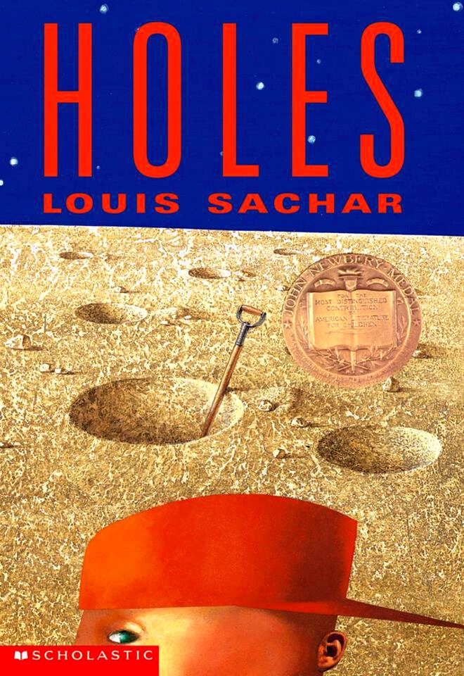

Autumn term: half term 2

***Year 6 Parent Communication***

