|  |
| --- |
| **Once upon a time…** |

|  |
| --- |
| **Reception Knowledge Explorer** |

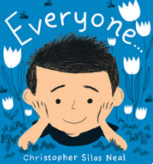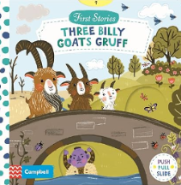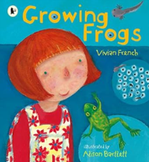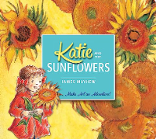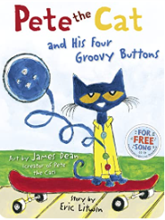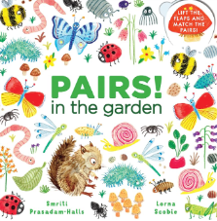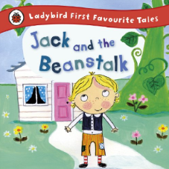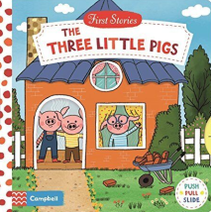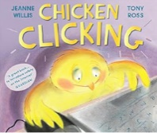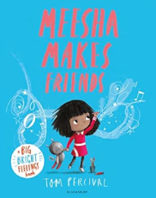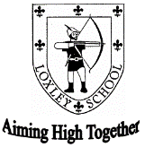

 How you can help at home

* Help your child to become familiar with the topic words and the meanings.
* Please share any traditional tales and other books you have at home. Talk about the past when reading traditional stories.
* Explore the author and the type of book. Is it fiction or non-fiction?
* Encourage your child to spot familiar words and repeated phrases when sharing stories.
* Encourage your child to ask family members about their favourite stories.

Our focus texts will be:

|  |  |
| --- | --- |
| **Key Vocabulary** | |
| Traditional tale | A story for children that is old or well known. |
| Character | A person, animal or figure in a story. |
| Setting | When and where a story takes place. |
| Church | A place of worship for Christians. |
| Mosque | A place of worship for Muslims. |
| Life cycle | The changes that a living thing goes through from the beginning of it’s life until death. |

The children will explore life cycles this half term, and we are lucky enough to have our own caterpillars in the classroom for the children to observe as the grow and change. We will also be learning about the life cycle of plants and growing our own sunflowers for the children to bring home.

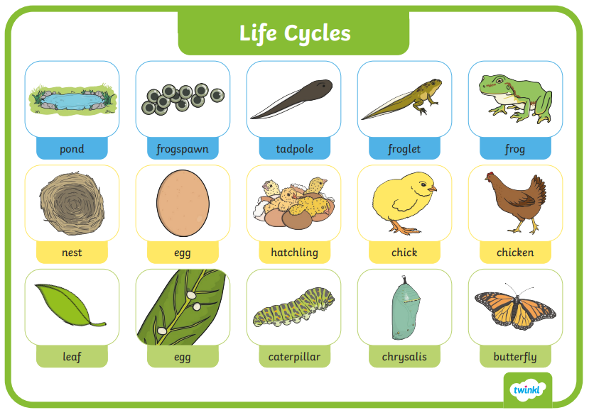

|  |  |  |  |  |
| --- | --- | --- | --- | --- |
| We are looking forward to Sports Day which will take place during Health Week. We will also be looking g at other ways in which we can be healthy. Please discuss different ways to be healthy at home. We will be asking the children ways in which they are healthy outside of school, such as attending sports clubs and eating healthy, balanced meals. |  |  |  |  |