|  |
| --- |
| **Our main texts will be:** |

 How you can help at home:

Help your child to become familiar with these

words, the meanings and some of the facts about

light/ dark, festivals and celebrations.

Talk about things you celebrate with your family?

How many different celebrations can you think of?

 Go on a light hunt…. See how many light sources you can find in the house and outside.

|  |  |
| --- | --- |
| **Key Vocabulary** | |
| **Diwali** | A five day Hindu festival to celebrate the New Year |
| **Festival of**  **Lights** | Another name given to Diwali. People light hundreds of lamps, called divas. They can be found in houses, shops and in the streets. Divas are usually made out of clay. |
| **Hindus** | People that follow the religion of Hinduism. |
| **Bonfire Night** | Bonfire Night is celebrated in the UK on the 5th November every year. We celebrate it because in 1605, a man called Guy Fawkes and his friends from York decided to try and blow up the houses of parliament. |
| **Birthday** | The anniversary of the day a person is born. |
| **Christmas** | A festival celebrated by Christians on 25th December to celebrate Jesus’ birth. |
| **Christians** | People that follow the religion of Christianity |
| **Nativity** | The story of when Jesus was born. |
| **Bethlehem** | The town where Jesus was born. |
| **Winter** | A season, in which days are cold and short. This means it gets darker earlier. |
| **Nocturnal** | Animals that are active at night. |
| **Diurnal** | Animals that are active during the day. |
| **Reflection** | When light from an object is reflected by a surface. |
| **Shadow** | A dark shape made when something stands between a light and the surface. |

|  |  |  |  |
| --- | --- | --- | --- |
| Diwali | Bonfire Night | Birthdays | Christmas |

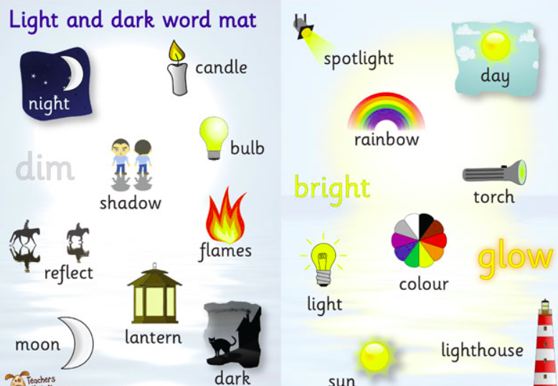

**Light & Dark**

**Reception Knowledge Explorer**

